CONTACT INFORMATION
Co-Chairman: Terry Holman
Email: thereseholman@gmail.com
Cell: 908-963-9227

Co-Chairman: Susie Middleton
Email: sjm21613@gmail.com
Cell: 443-604-7677

Registrar: Diane Freestate
Address: PO Box 748
Centreville, MD 21617
Email: dianefreestate@gmail.com
Cell: 410-490-2149

SPEAKERS/VENDORS

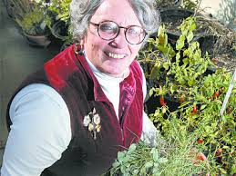
Barbara Melera is advisor to Harvesting History, a new horticultural company founded in 2016 to provide its customers with the finest quality horticultural and agricultural products available today. Its horticultural and agricultural products are largely heirloom varieties that can be reliably offered to customers year after year. Wherever possible, Harvesting History offers products Made in the USA. For 13 years, Ms. Melera was president and CEO of The D. Landreth Seed Company, the oldest seedhouse in America, established in 1784, and the fourth oldest US corporation.
Vendor: Barbara will be selling plants, seeds and other gardening products at her booth.

Michaela Boley, a Senior Agent Associate for the University of Maryland Extension service in Talbot County for Urban Horticulture. She has coordinated the Master Gardener volunteer program since 2012. Her expertise is in Native Plants of Delmarva, Landscape Design, and Bay-wise Practices.

SPEAKERS/VENDORS

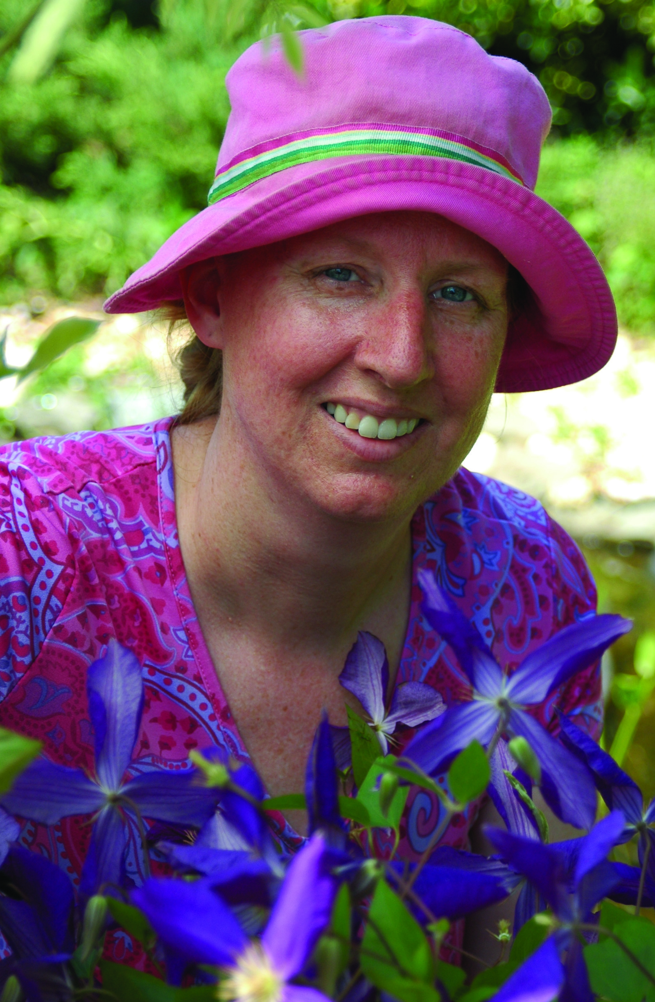
Kathy Jentz, Editor, Publisher and Founder of Washington Gardener Magazine, published specifically for zones 6-7. A life-long Gardener, Kathy believes that growing plants should be stress-free and enjoyable. Her philosophy is inspiration over perspiration. Kathy’s work can be read in the Washington Examiner, Washington Woman and she has regular guest spots on Channel 9, Channel 4 and WAMU radio.
Vendor: Kathy She will be selling her popular magazine subscriptions and other items at her booth.

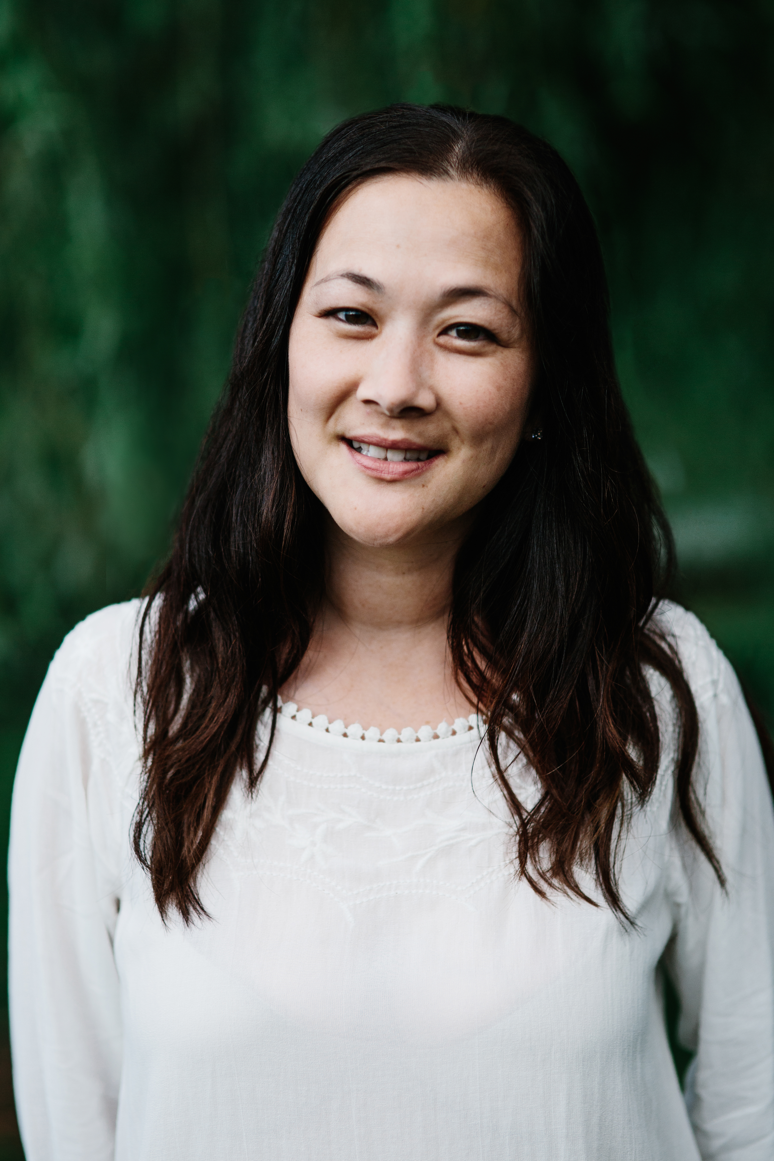
Wendy Kiang-Spray is a writer and speaker whose articles about gardening and food have appeared in national and local print publications. She gardens in Rockville, Maryland (zone 6) where she also works as a high school counselor. In her spare time, Wendy volunteers with the DC Master Gardeners and blogs about gardening and family at www.greenishthumb.net. Her first book, The Chinese Kitchen Garden, was released by Timber Press and is about growing and cooking Chinese vegetables. Learn how to grow and enjoy a wide variety of Asian vegetables such as chrysanthemum greens, luffa gourds, bitter melon and many more with growing tips.
Vendor: Wendy will be autographing and selling her book, The Chinese Kitchen Garden at her booth.

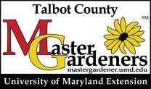
The Talbot County Master Gardeners:
Master Gardeners will be on hand at their booth with educational gardening handouts, soil test kit information and happy to answer any garden related questions.

Arboc Orchids Roger Cole will be selling beautiful orchid plants and sharing his orchid growing expertise.
“PLANTING AMERICA”
A Day Dedicated to Horticulture

Sponsored by District I
Federated Garden Clubs of Maryland, Inc.
Member of
National Garden Clubs, Inc.
Central Atlantic Region of State Clubs

Open to District I – FGCMD, Inc.
Garden Club Members,
Master Gardeners
and the Public
Wednesday,
April 18, 2018
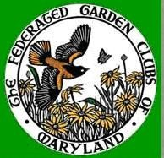

The Easton Volunteer
Fire Department
Fire Hall
315 Aurora Park Drive
Easton, MD 21601

GENERAL INFORMATION

Any interested person is welcome and invited to
attend this day dedicated to horticulture with great speakers whose varied and interesting presentations will educate everyone with gardening techniques to help Plant America.

Please bring a pad and pen to take notes to share with your friends and fellow garden club members.

“Planting America”
Schedule
*subject to change

WEDNESDAY, APRIL 18, 2018
6:45-8:00am Setup
8:00-8:45am Registration, Hospitality,
and Vendor Shopping
8:45-9:00 am Welcome and Announcements
9:00-9:50 am Kathy Jentz– “Regionally Adapted Plants”
10:00-10:50 am Barbara Melera- “My Tomatoes are Ailing”
11:00 -11:50 am Mikaela Boley- “Best Gardening Practices”
11:50-12:50pm Lunch and Vendor Shopping
12:50-1:00pm Announcements
1:00-1:50pm Wendy Kiang-Spray- “The Chinese Kitchen Garden”
2:00-2:50pm Barbara Melera- “The Art and Science of Saving Seeds”
3:00pm Closing Announcements/Vendor Shopping
4:00pm Cleanup

Driving Directions

From Centreville, MD US 50East:
- From US 50 East take exit MD-322 South (A Slight Right Turn)
- Turn left at light onto North Washington Street
- Turn Left onto North Aurora Street.
- Public Street Parking

From Cambridge, MD: US 50West:
- From US 50 West turn LEFT onto Dover Road in Easton
- Turn Right onto North Aurora Street
- Public Street Parking

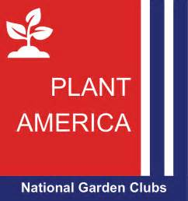

*Look for signage of this event
*Please carpool as parking spaces are
limited
*Please Do NOT block Fire Engine driveways

“Planting America”
REGISTRATION FORM
Registration Deadline: April 10, 2018
Note: After this date, contact Registrar to
Determine if seating is still available.
~Please make a copy for your records~

________________________________________
Name

________________________________________
Address

________________________________________
City/State/ Zip Code

________________________________________
Area Code/Telephone (Cell)

________________________________________
Email Address for confirmation

__________________________________________
Denote Garden Club Affiliation (if any) and If you are a Master Gardener

Box Lunch Choices: Check one;
1. Power Veggie Sandwich
Fresh Veggies, Roasted Pepper Hummus and
Jack Cheese on Whole Grain Wheat Bread
2. Tarragon Chicken Salad Sandwich
On Brioche Bread
3. Roast Beef with Brie and Horseradish Mayo
On Baguette

Lunchbox Includes: Sandwich, Veggie Power Slaw, Cookie, Pickle, Chips and beverages. Coffee, Tea and morning/afternoon treats included in price.

FEES
Program (includes Lunch).................. $42.00

Total Remittance: $_____________
Make Check payable to: District I–FGCMD, Inc. Mail form and check to Registrar, Diane Freestate (See Contact Information for address)
Please note: No refunds issued after April 11, 2018 Registration confirmation will be emailed if received by April 10, 2018.

